Practical Test 2

By

Buwaneka Hettiarachchi

SID 104376165

RIS 502

December 14, 2021

Contents

Executive Summary 2

Engagement Methodology 3

Information Gathering 3

Focused Penetration 3

Post Exploitation/ Privilege Escalation 3

Documentation 4

Attack Narrative 4

Broken Access Control: Administration Page 5

Improper Input Validation: Manipulating the Cart 6

Cross Site Scripting: Performing an XSS Alert 9

Improper Input Validation: Changing the Upload File Type 13

SQL Injection: Perform an SQL injection command in the Login 17

Technical Observations 22

Appendix: Severity Definitions 22

Broken Access Control: Administration Page 22

Improper Input Validation: Manipulating the Cart 22

Cross Site Scripting: Performing an XSS Alert 22

Improper Input Validation: Changing the Upload File Type 23

SQL Injection: Perform an SQL injection command in the Login 23

Appendix: Host and services 23

Appendix: Tool and services 23

Appendix: Additional Resources 23

# Executive Summary

The goal of this penetration test was to apply known pen testing skills is to perform web application attacks filled with vulnerabilities and exploit up to 5 vulnerabilities and bugs present in the environment and give a detailed understanding on how the that attack applies to the specific bug. The scope of this penetration testing environment is to test a web application known as Flo Natural Flowers. The Pen testing environment was performed within a Kali Linux System and our team used a tool known as Burp suite. Burp Suite is a tool that is already installed in the Kali Linux environment and its main purpose is to serve as a tool which is capable in discovering vulnerabilities and performing penetration testing through the use of intercepting into a target application. The penetration test took place in a range of two days starting from Monday, December 13, 2021, at 11 AM and Finished and Finished on Tuesday, December 14, 2021. As a result, the penetration test ended with a highly successful, where the pen testing team was capable in exploiting 5 known bugs that were present within the Web application on the exclusion of 1 bug having some database issues and will be further demonstrate in the report.

# Engagement Methodology

## Information Gathering

In terms of information gathering, we used our pen testing skills to identify some areas where it might have possible loopholes that might be present within the system. Some of the areas that we were able to identify that might have possibilities openings are the web application directories, the login page, the cart, and the guest book. These areas seems vulnerable due to the fact that most of them have user interactions where uses can freely add in comments even without being a registered user. Some of the Attacks that are really intriguing for us were the Broken Access control, Injection attack, Cross site scripting, and Improper Input validation.

## Focused Penetration

To compromise the web application, we were already given the IP address of the web application and we have 2 methods where we can penetrate into the system to gain insight information of the web application. Both these methods include the use of Burp Suite, the first Method involves in us using a normal web browser such as Firefox or Google Chrome, and open the web application, then we would make the web application as a proxy server to directly connect with Burp Suite, to do that we have to go to the browser settings and change t to the likings of Burp Suite. The second Method involves in us using a similar type of approach as Method 1, but in this method, we open a browser within Burp suite, Burp Suite has a feature known as Open Browser, that is situated within the Proxy settings, by opening this server, we can open a browser directly from Burp Suite that is already acting as a Proxy.

## Post Exploitation/ Privilege Escalation

To Exploit the Web application wasn’t really as difficult as expected because when we were looking into the Burp suite target page, we were able to identify directories that we can’t really open changing the filter, we were able to open most of the directories, these include directories such as the Images directory, which includes all the information of all the image files and their sub directories, these types of directories can’t be accessed by normal unauthorized users because these are files that are used to show the output of the web application file. The Figure below shows how it was possible to identify that these directories exist in the web application.

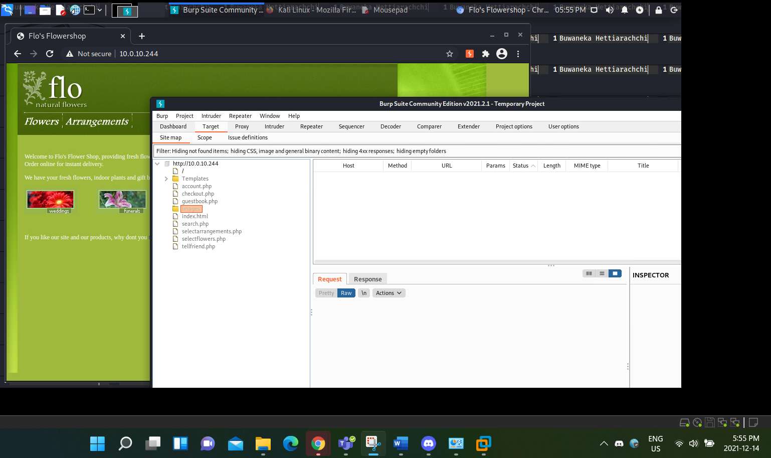

Figure 1: Showing Directories I can't Open

The above Figure showing the directories that are present within the Web application, that can only be viewed by authorized individuals, we can filter to show al the hidden results and it will give you information of the directories, this is one of the ways we were able to escalate the privileges in the Web application. This methodology was an opening for how we were able to get into the Administration page, which will be further informed in the Attack narrative component of the report.

## Documentation

This phase involves with the pen tester grabbing many evidences such as screenshots of the lab environment with the date and time to show the proof of legitimacy. Screenshots are mainly involved in the attacks that were performed and all these screenshots were put into a rough draft that will carry all the attack information with a small description of what each Figure represents. This report works as the final delivery of all the attacks with an in-depth explanation to them.

# Attack Narrative

This section focuses on a detailed walkthrough of the attacks that were performed in the penetration test on the web application. As discussed in the above component, the attack categories that were performed in this section are Broken Access Control, Cross site Scripting attack, SQL injection attack, and the Improper Input validation. These will be explained in a detailed method.

## Broken Access Control: Administration Page

This attacks involves with us gaining information on how to get into the web application’s Administration page. First method was to go into the Web application and then Intercept the Web application with Burp Suite. These methods are shown below.

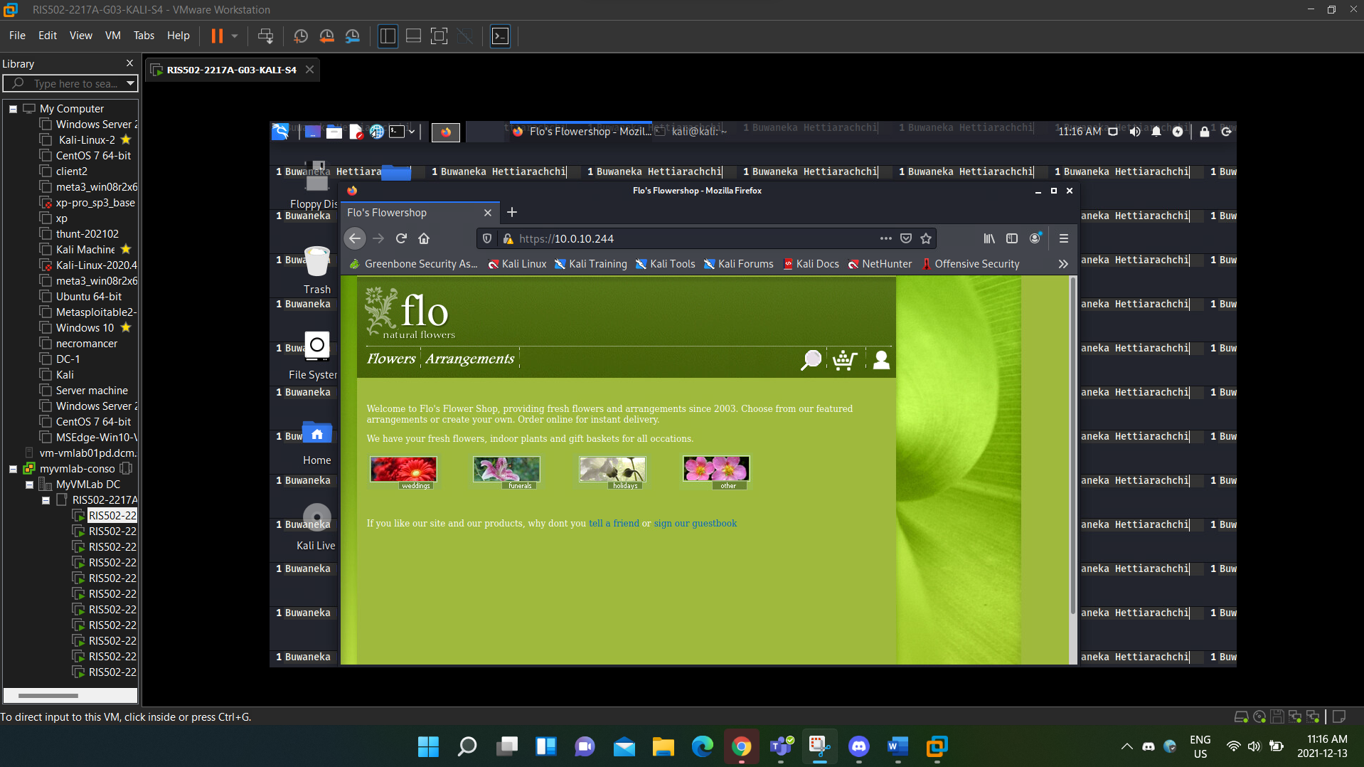

Figure 2: Searching the Target IP address in the Web browser will give you into a web application

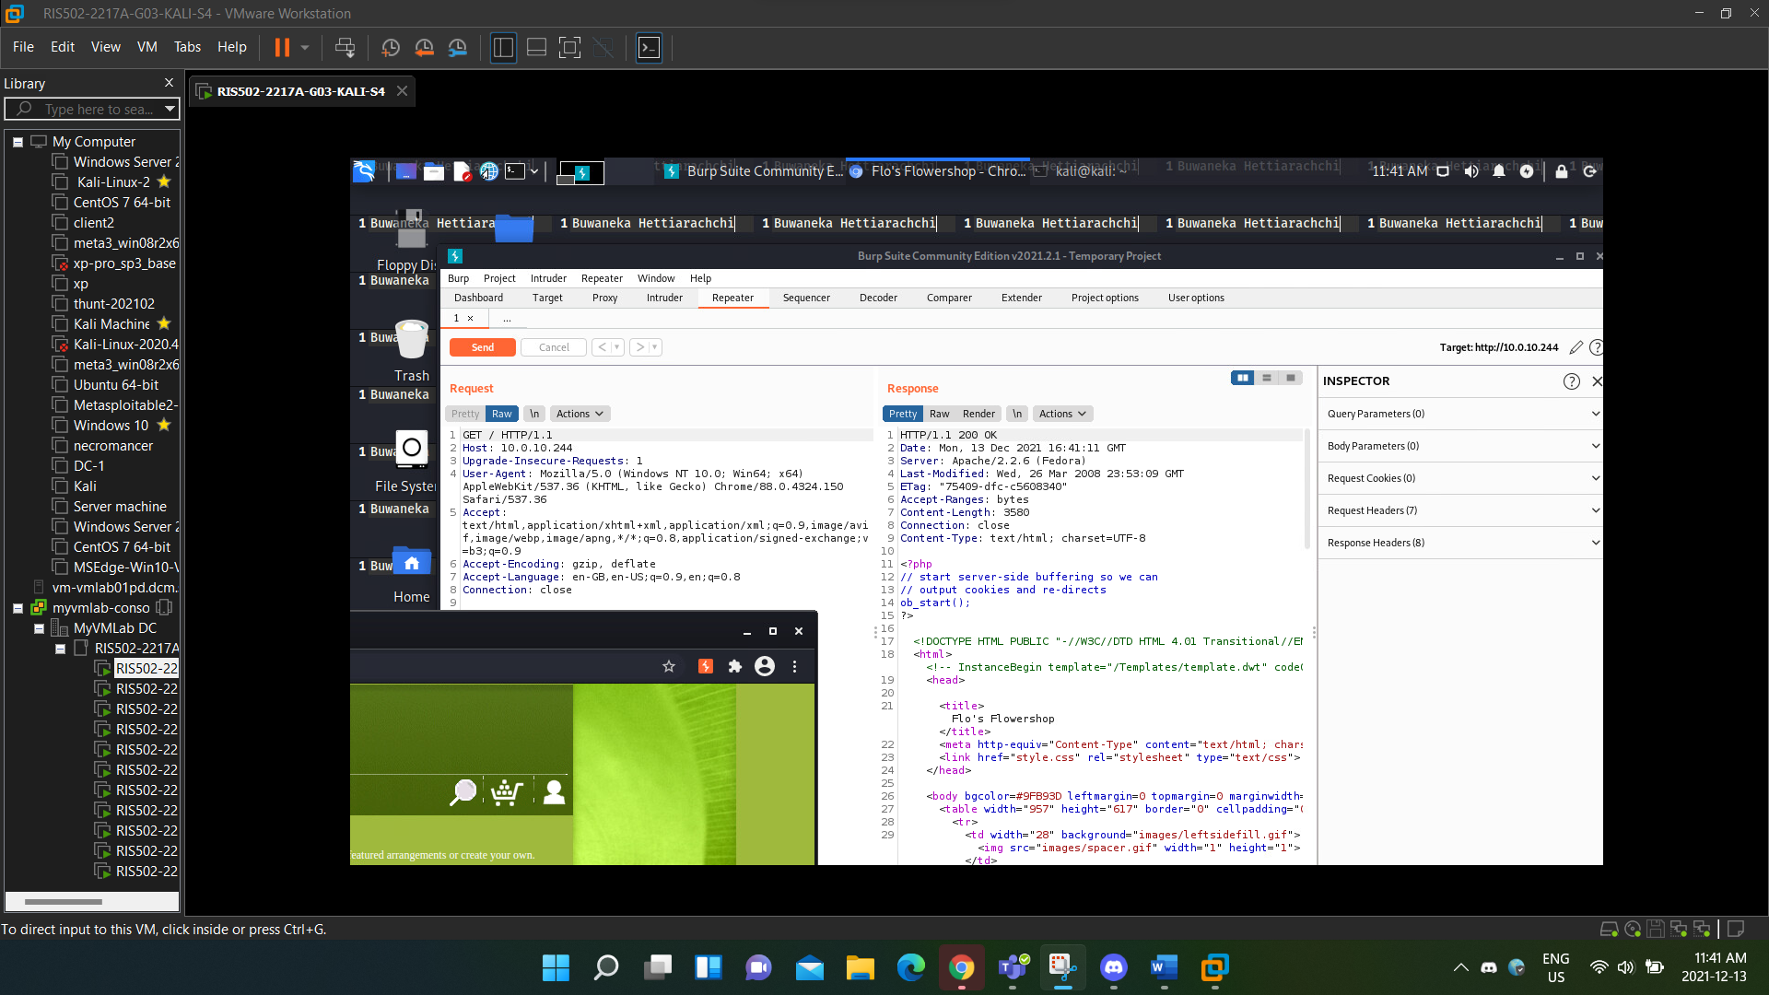

Figure 3: Intercepted the Webpage using Burp Suite

In the above figure, we can see that the Request section gives us a GET result with a input of (GET /), which means that we are requesting the Get the main directory or the homepage of the Web application. Since we were able to understand how these requests were working, we tried to use a brute force method into getting into the administrative page, we tried many instances such as (/Administration, /Admin, /Administrative), but nothing seemed to be working. However, we were able to identify the directory by editing the get request by performing the request GET /admin/, which gave us the result shown in Figure 4.

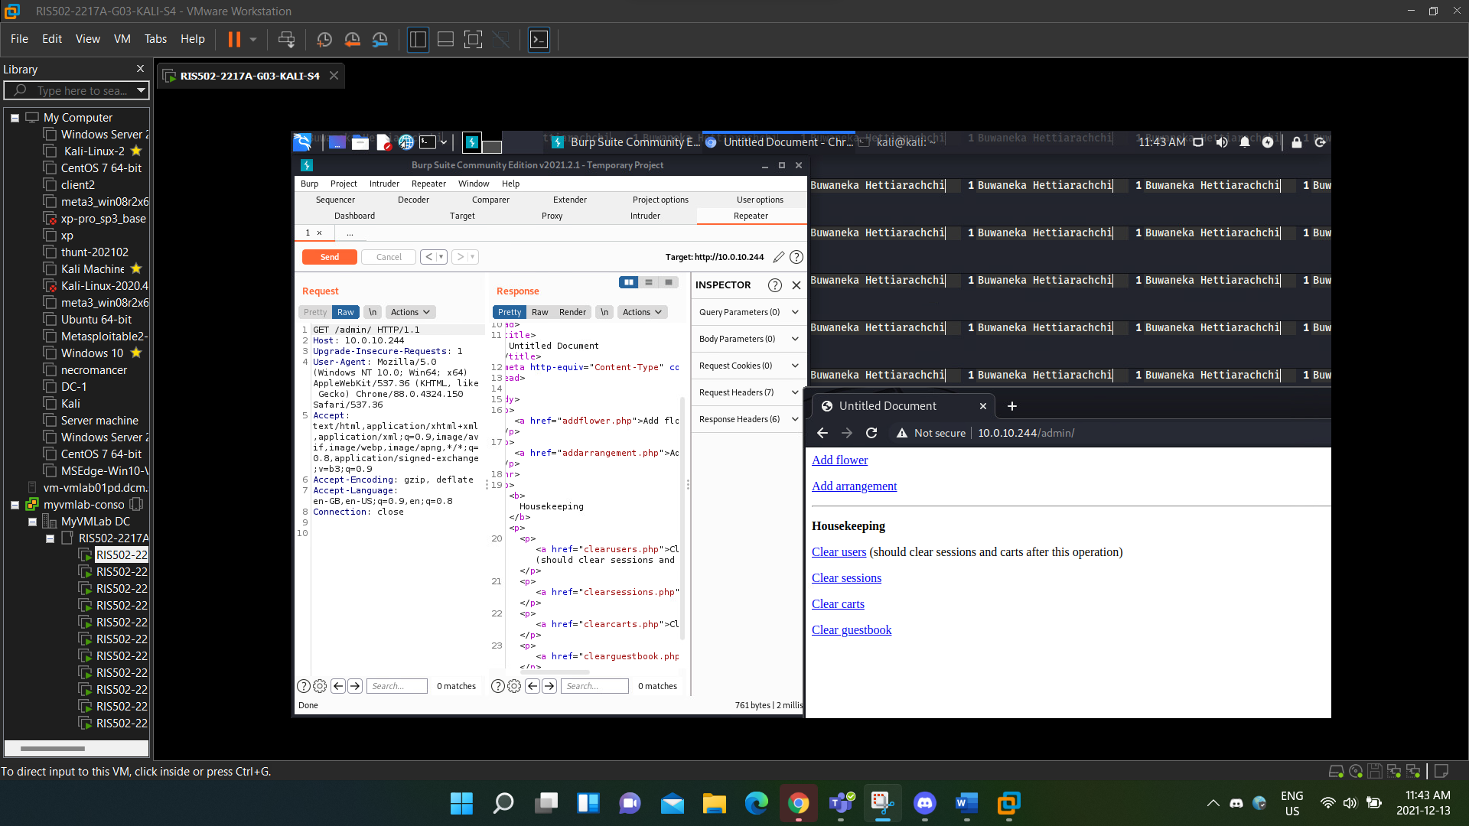

Figure 4: By editing the GET request to /admin/, we were able to get access to the admin page

As shown in the above Figure, we were able to successfully get access into the Administrative page of Flo Natural Flowers Web application. In the Admin page, wee have access to add in flowers and arrangements to the directories. And there is a section called Housekeeping, which is used to clear users, sessions, carts, and guestbooks. These actions can only be performed by a Admin and thus proven that this attack was successfully delivered.

## Improper Input Validation: Manipulating the Cart

This attack require us to perform an Improper Input validation on a Cart function of the web application. The cart function is used to add in items such as Flowers and Arrangements and go to a purchase. But there seems to be bug because we were able to discover that the items in the cart shows the quantity and other information in Burp suite. To perform this attack, we must first create a user because we cannot go through a purchase without creating login. In this scenario I chose the name of the user as RIS User and the registration of the user requires us to add in information such as Address and card information, something that off in the card information was the card expiry dates only came up to the year 2015, so technically we are doing purchases using an imaginary card that is already six years on its expiration.

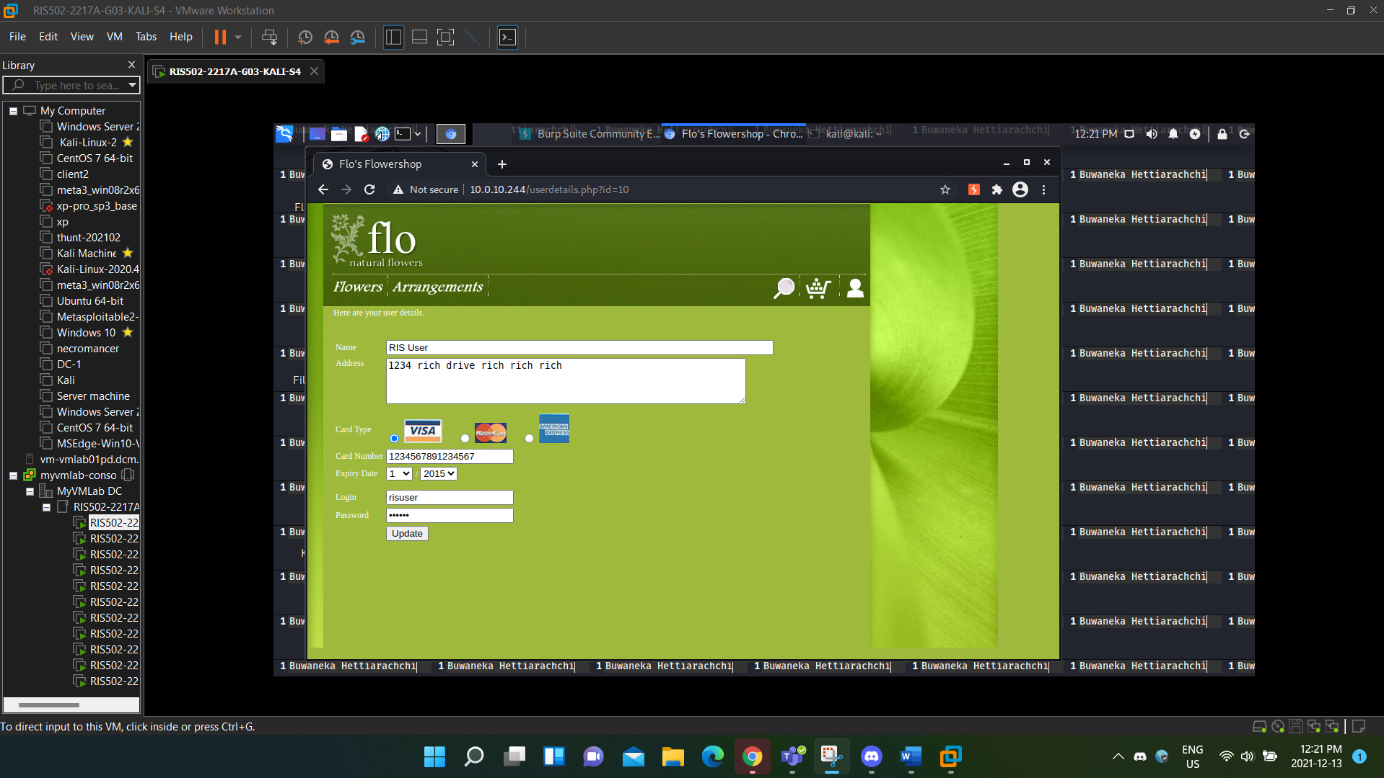

Figure 5: Create a User called RIS user

After creating the user, I went into the main page and selected the flower that I was interested in, while browsing through the flowers, I started to Intercept Burp Suite to catch in the details of the flower that I put into the cart. When I selected the flowers and clicked on the cart icon, Burp Suite gave the following information.

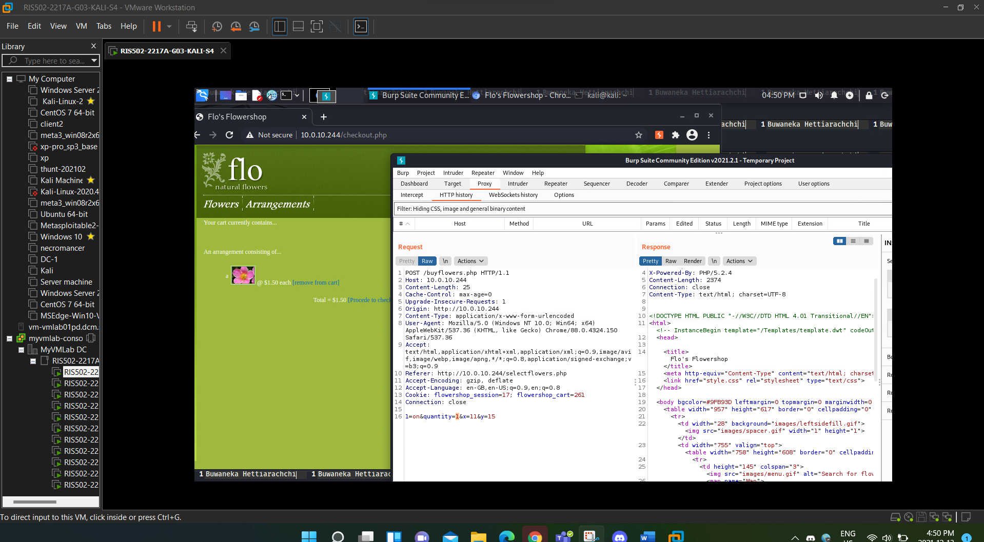

Figure 6: When purchasing the quantity of the flowers, Burpsuite shows all the details

The given information are that the I have ordered 1 quantity of the of the Unit ID 1, this means that I have ordered just 1 quantity of the first flower in the flower section, So I began the interceptor and added in a negative value in the Burp Suite environment, in this case I added in -1000 quantity.

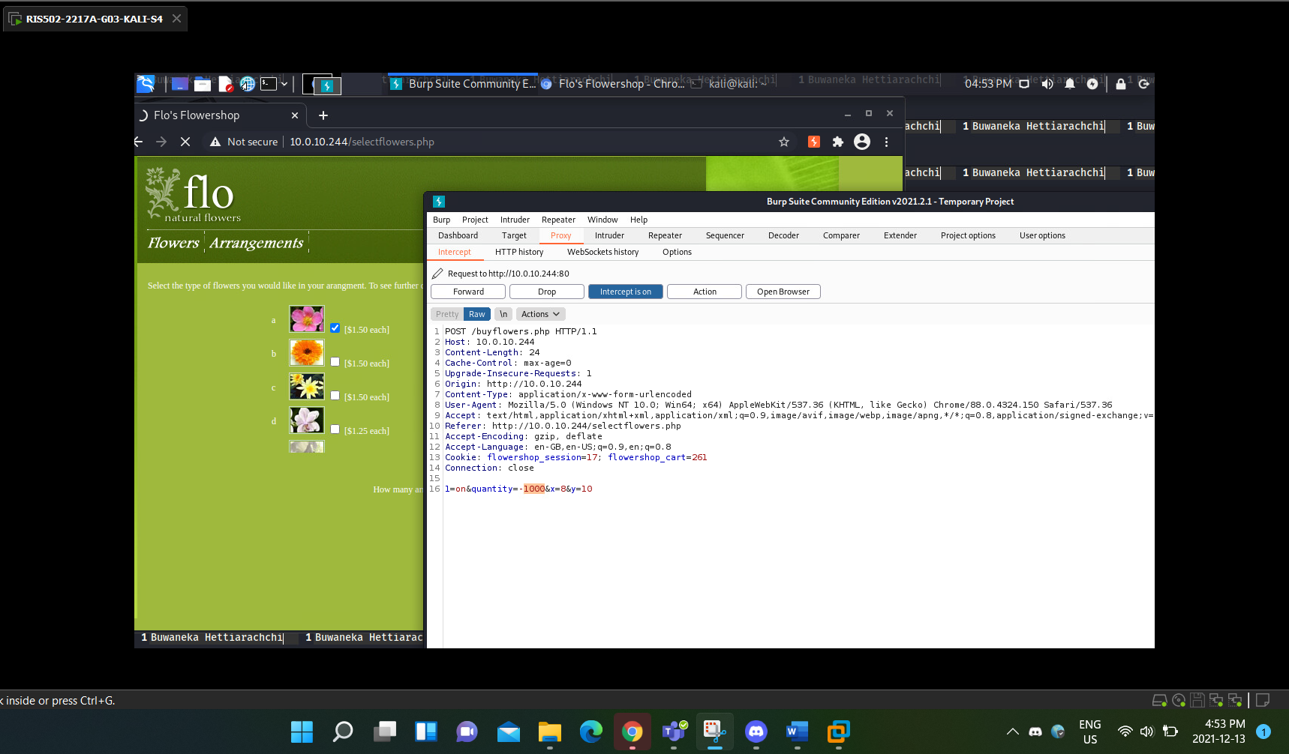

Figure 7: Turned on the Burpsuite Interceptor to change the Quantity from 1 to -1000

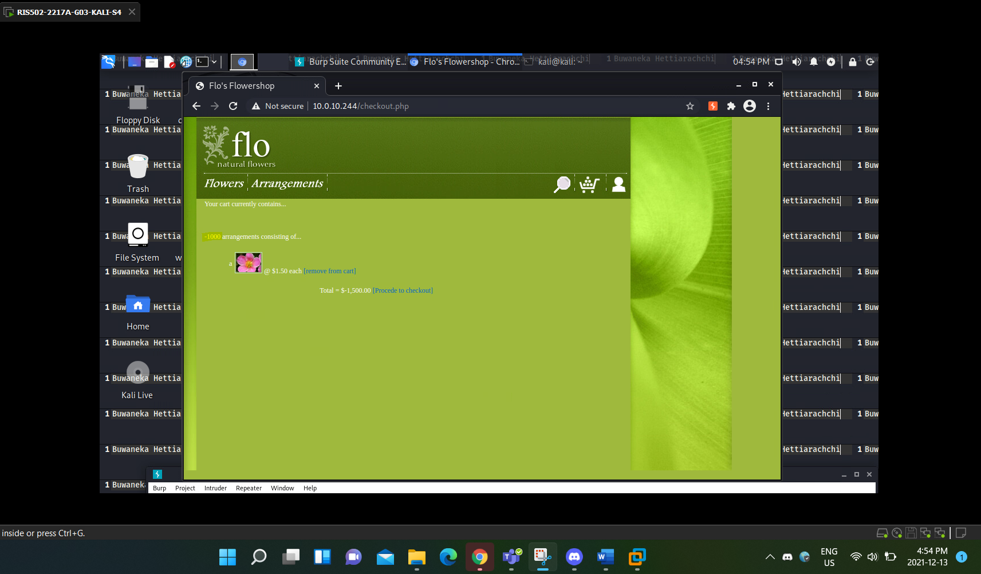

Figure 8: Successfully manipulated into making them refund me money

And as the above Figure shows, we can see that there is an arrangement of -1000 quantity of Flowers. This means that instead of us paying the money for the Flower shop, they will have to refund us 1500 dollar, which instantly makes us rich without even performing a purchase.

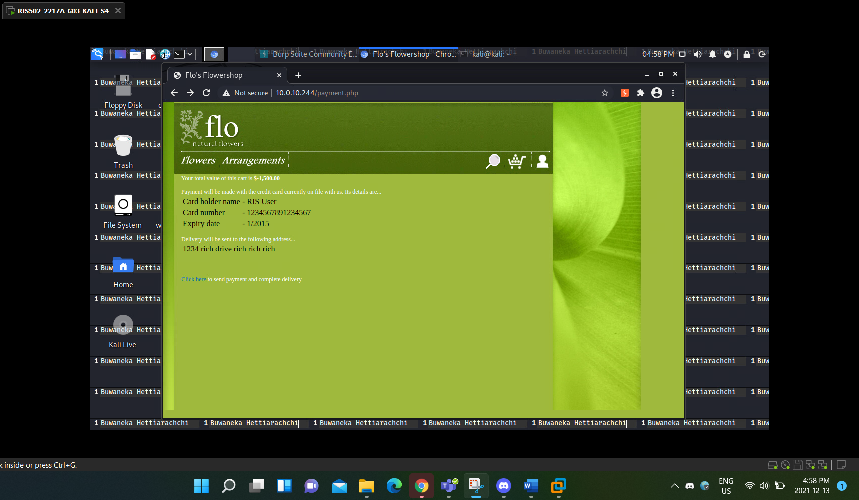

Figure 9: The attack is successfully delivered

As shown above, I was able to successfully deliver the attack as it shows that we are supposed to pay -1500 dollars to the delivery. This shows that if there are proper misconfigurations or any exposed information related products, those misconfigurations can be used as an exploit to perform such attack that will be costly.

## Cross Site Scripting: Performing an XSS Alert

Cross site scripting is an attack that is used as a script which goes onto performing malicious actions on websites and web applications the main purpose of an XSS attack is to send a malicious code in to the web application. In this section we are trying to perform an XSS attack with the main functionality of trying to show a simple alert by typing in a script and executing that script within the web application environment. Now to perform this attack, we searched through the entire Web application to try to find a loophole that can act as the platform to perform an XSS script, First we thought the search bar would be the nominate but turns out it has a limited search length, and our script exceeded that limit, and it was a failure when we try to do it through the use of Burpsuite. The Tell a Friend page did no help either. Lastly we went into the Guest book, and we can see that the guestbook is used for customers to post information on it, and it is the right platform to perform the attack on.

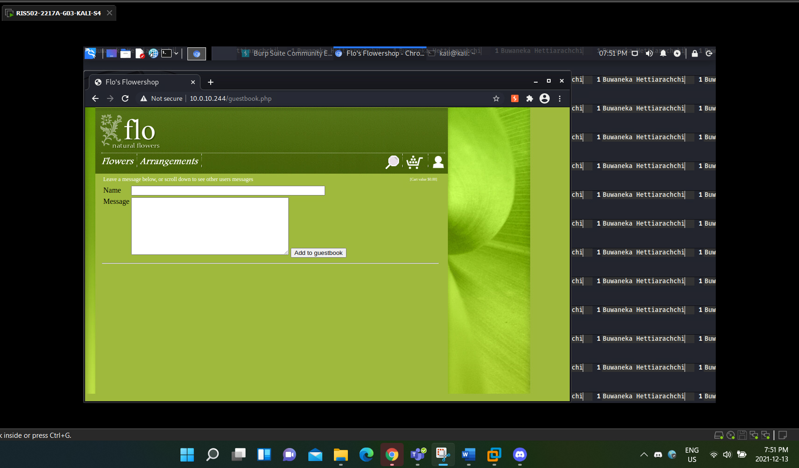

Figure 10: The Guest Book is where users can put down a comment about the flower shop

To perform the attack, I simply wrote the word “hi” in the Name field and then before adding it to the guest book, I opened the Burp Suite Interceptor on.

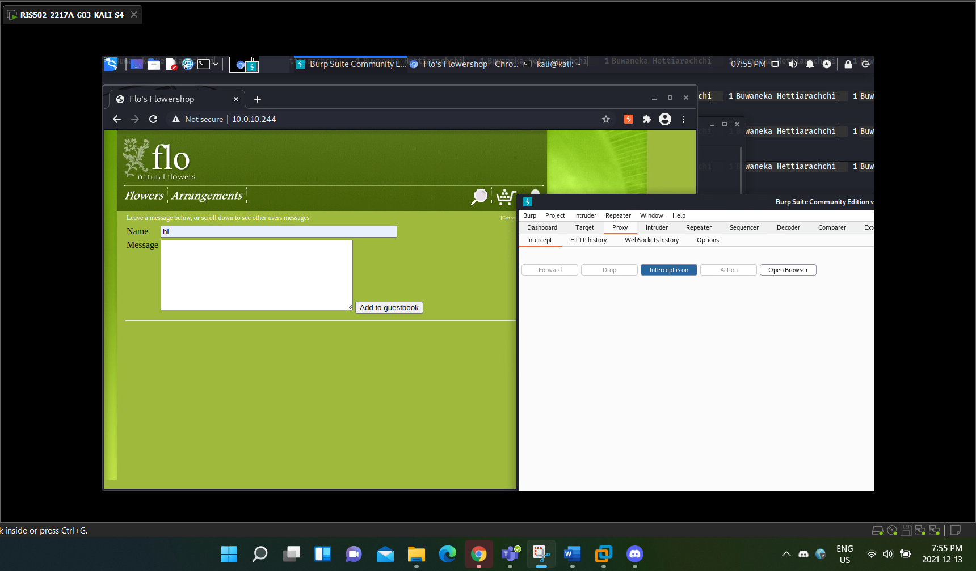

Figure 11: I put in a message saying "hi" in the name box while the intercept is on

After tuning on the Interceptor, I went to add in the Comment to the guest book. By adding in that comment, I got the following Information from the Burp Suite Interceptor.

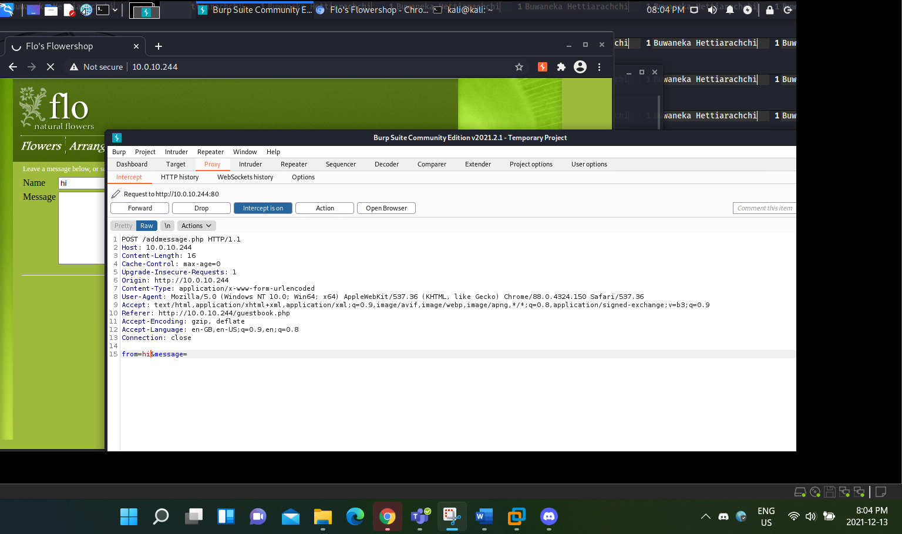

Figure 12: Message showing on the Burpsuite Interceptor

By looking at the Request message, we can see that at the bottom there is a filed known as From and Message. In the From field, we can see the message that we posted. Instead of posting that, we will be putting in a XSS script, this script is an XSS alert script which comes in this form(<script>alert()</script>). What this script does is that, when we forward this script to the web application it will give us a popup alert and when ever we come into the guestbook this alert will always popup. And you can see that in the script, the alert section I kept it as two black parenthesis (), we can actually add in any value in the middle like ‘XSS’ or even numbers, what that does is that the alert will show up with the string that you added in. In my case I didn’t add any, so it will only give us a blank alert with the IP address of our web application mainly because I tried putting the strings like ‘Error’ but ended up getting and SQL error, so I opted to keep it clear. The Figures below will show how I performed the attacks by first applying the script in place of the word “hi” and then by Forwarding that message we got the Alert, shown in the Figures Below.

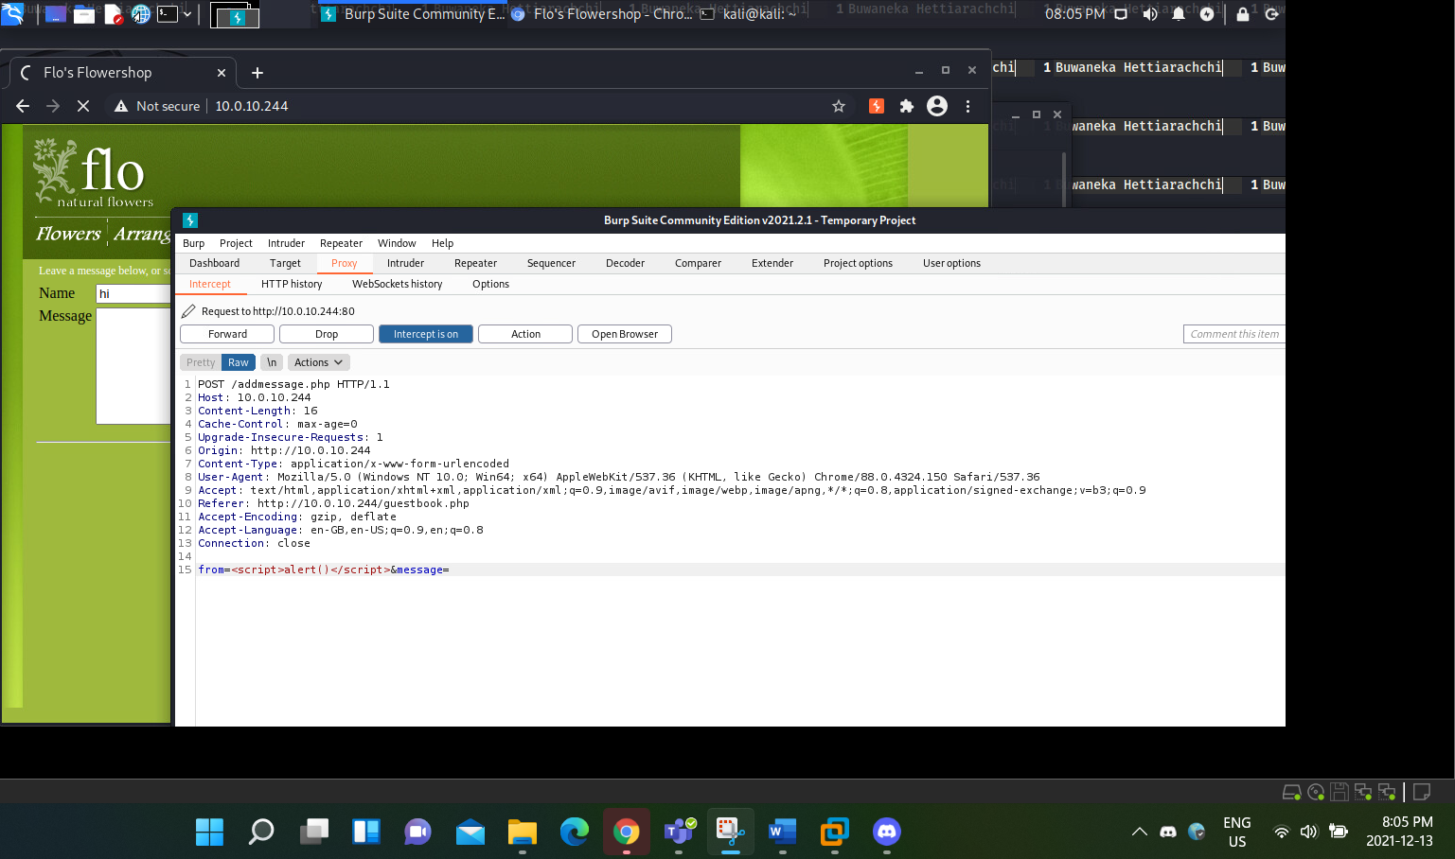

Figure 13: Instead of the message "hi" I am inserting an XSS alert script

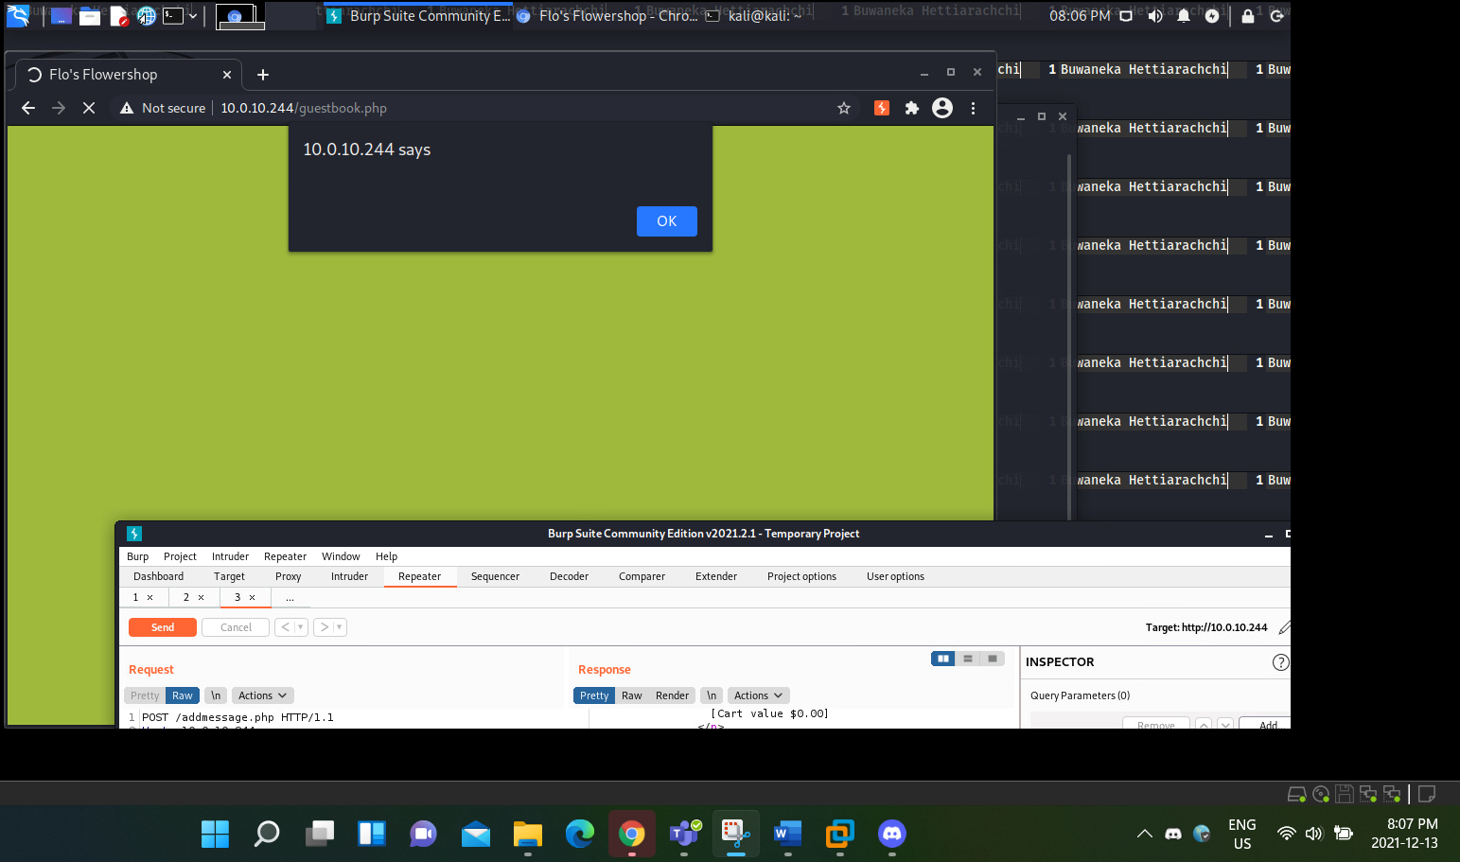

Figure 14: Successful XSS attack has been delivered

## Improper Input Validation: Changing the Upload File Type

This section of the attack narrative involves with us trying to change the type of file that can be uploaded into the web application. To properly perform this attack, we need to go into the Administration page. The main goal is to try to upload a PNG file, but we will see why we are unable to upload a PNG file.

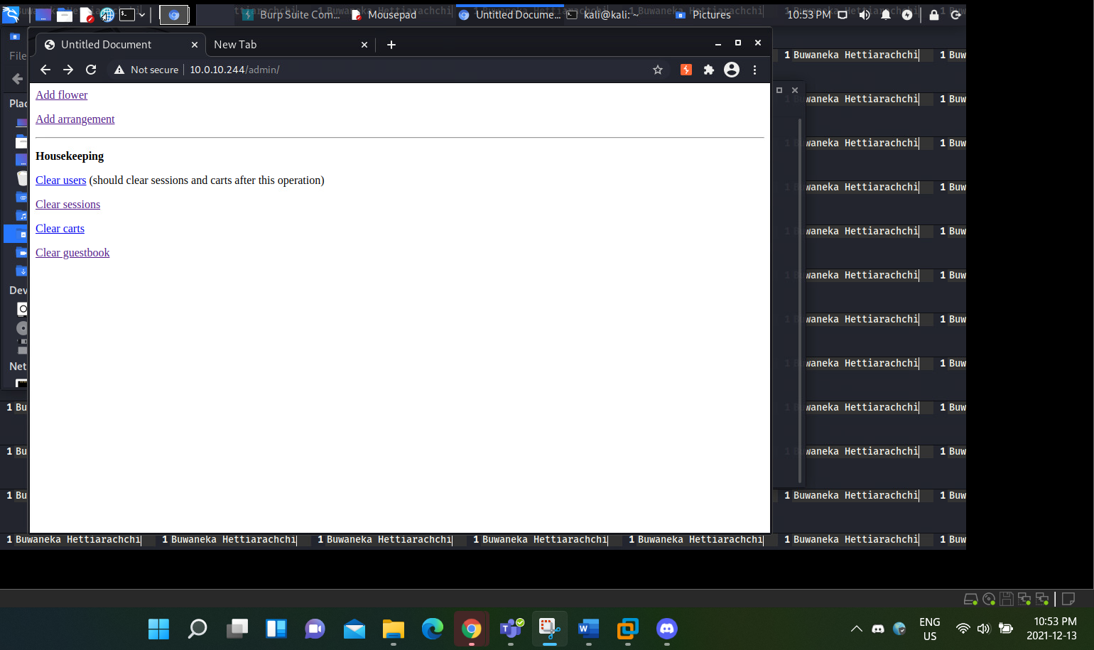

Figure 15:The Admin Page showing the Add flower feature

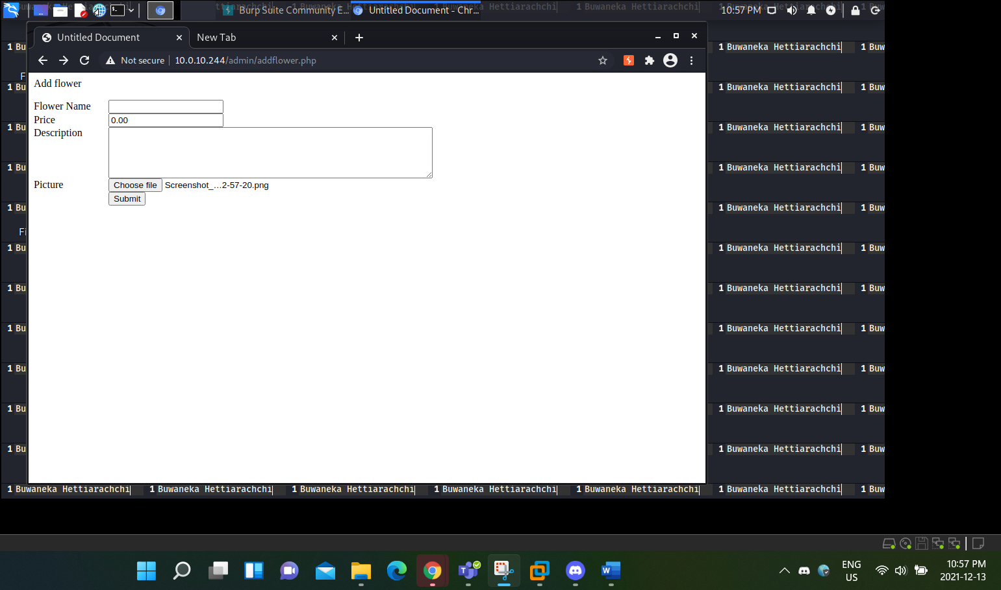

Figure 16: Trying to Submit a PNG document

When we are trying to upload this file into the web application, we can see that it doesn’t allow any other file except for GIF files.

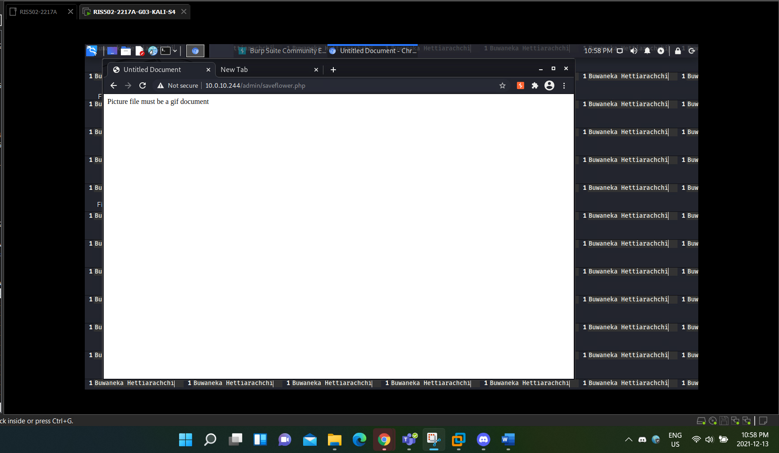

Figure 17: The picture must be a GIF

So, since the application doesn’t allow any other files except for a GIF file, what I did was I went into the Image Directory and installed one of the flower pictures, which are in GIF format. We can either do it using that method or we can just right click one of the flower pictures from the main homepage of the Web application and save it as well. Before uploading the GIF file, I turned on the Burp suite interceptor and when I performed the submit button, T got an output showing all information regarding the GIF file and the significant information I was able to get was that the GIF file content had the word GIF in the heading of the file content. This is shown in the Figure below.

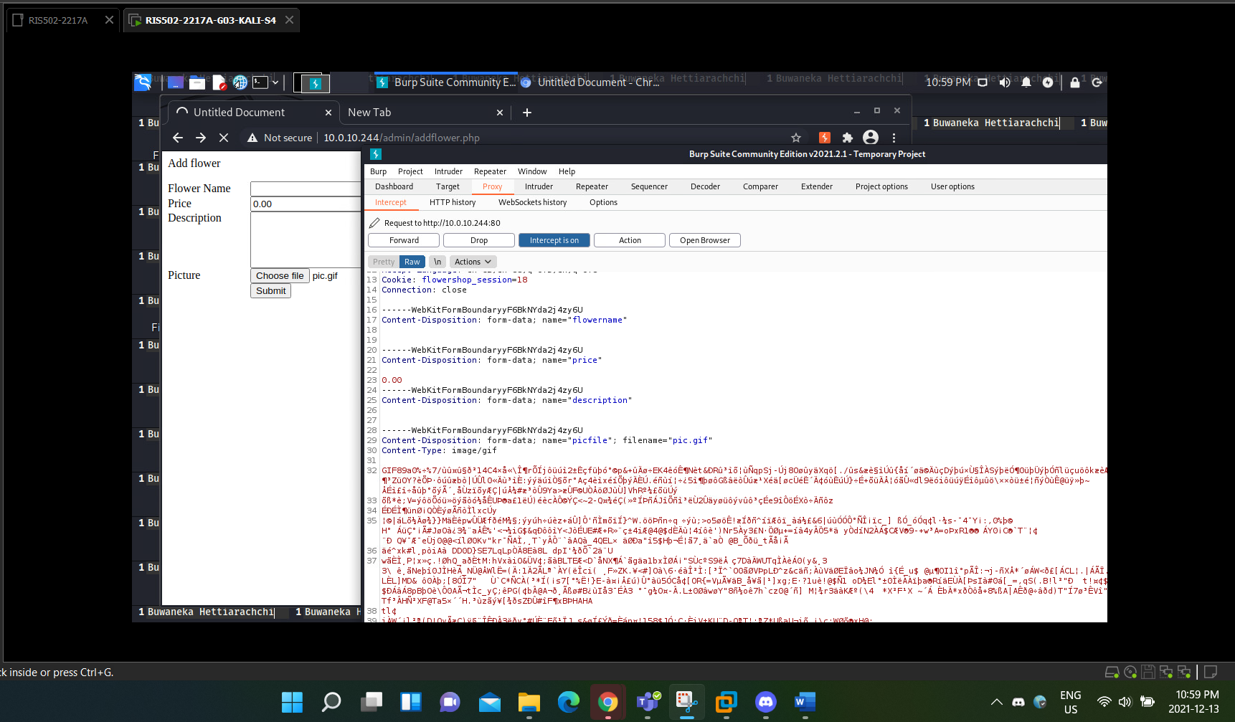

Figure 18: Trying to Submit a GIF folder

So, to perform this attack, I went to the PNG file and opened it in the Text Editor, which gives a similar input as the GIF file content.

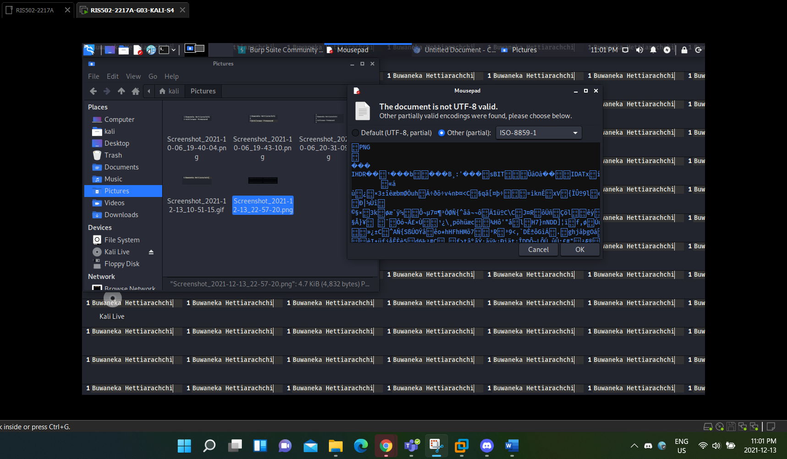

Figure 19: Copy the Text output and paste it to the GIF Text output

Then we went onto copy the PNG file content and as you can see, the PNG file content has a Heading that states that it is a PNG file. So, we copied the content and then proceeded to replace the GIF file content with the PNG file content.

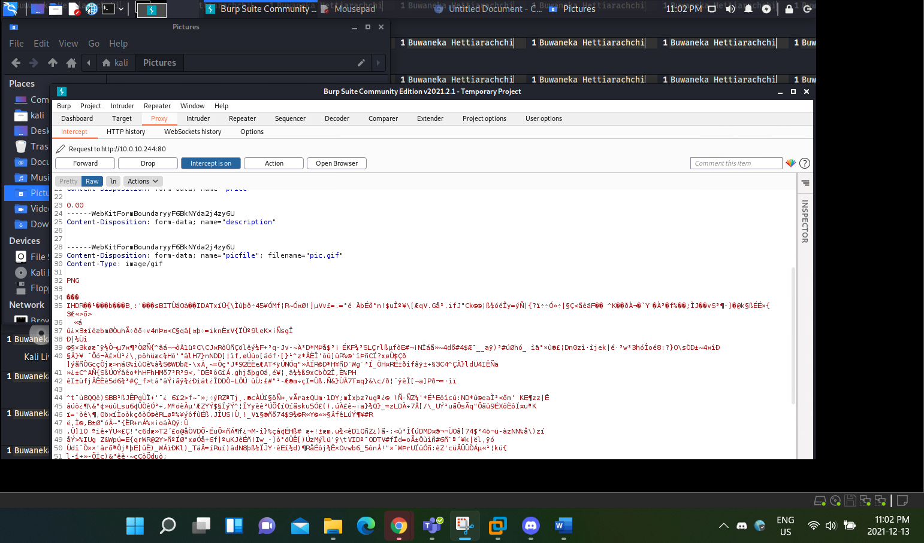

Figure 20: Replaced the Output

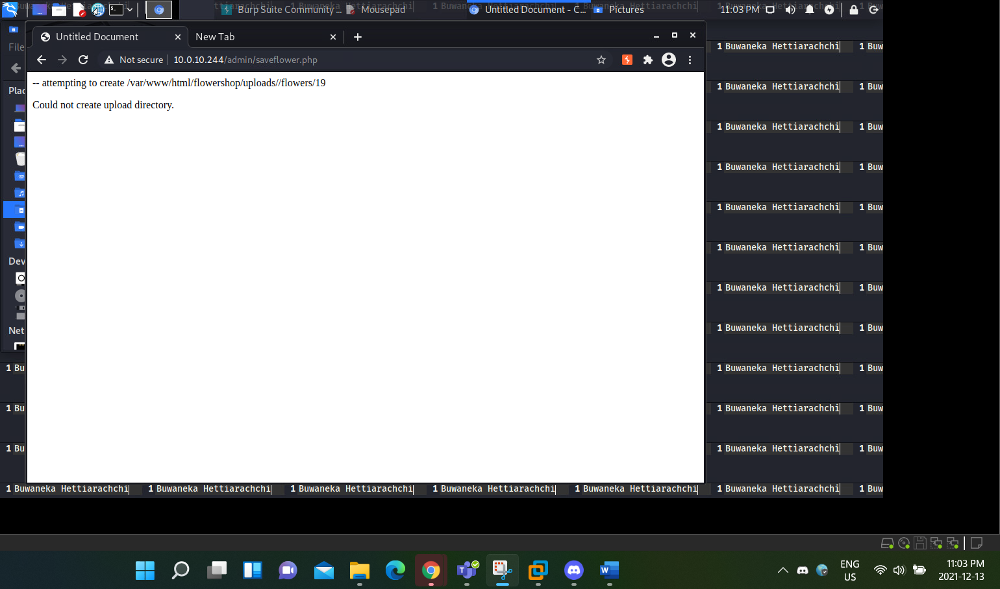

Figure 21: The file doesn't say wrong file type, but it couldn't be uploaded to the directory

As shown in the above Figure, I wasn’t completely able to submit the submit or create the directory, but it doesn’t mean it shows an error saying it’s not a GIF file like what was shown in Figure 17. I tried to apply just a normal GIF file, and it gives me a similar error, So in conclusion, what I think is that we can’t create additional directories in the sessions, but this does look to be the correct approach for an attack type that shows possibilities of it being an Improper Input Validation.

## SQL Injection: Perform an SQL injection command in the Login

An SQL injection is an attack form that is used to manipulate an SQL database into performing an action that is not authorized to do. The main purpose in this attack narrative is to perform an SQL injection through the login page to view the personal information of a user that is already created in the Web application. To begin this, I already created a which is shown in the Figure below.

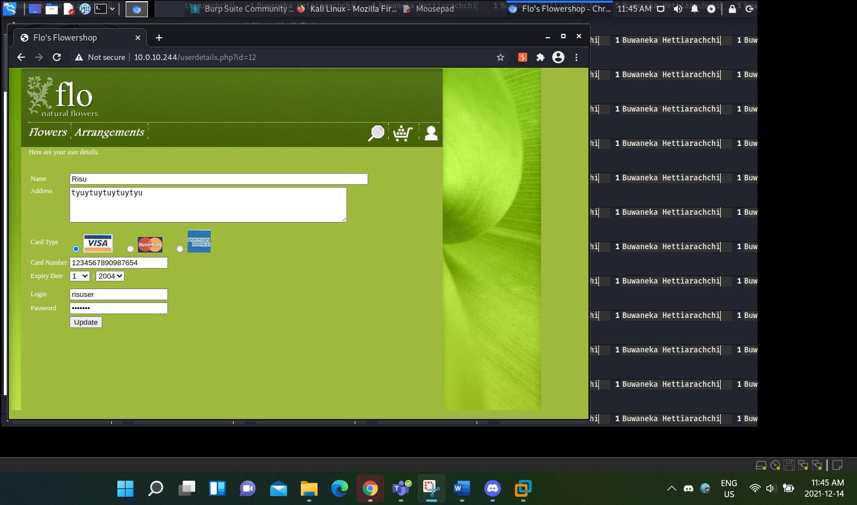

Figure 22: This attack focuses on me trying to reach this page by performing an injection attack

After creating the user, I logged out from the account, to do that, we have to go to the admin page and then clear the session, when you cleared the session, you should get an output that shows the below.

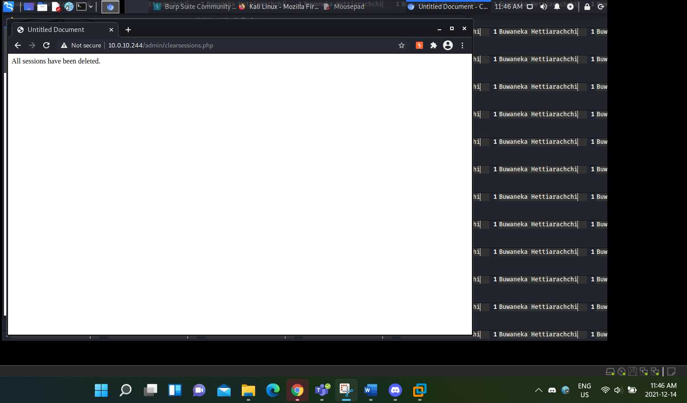

Figure 23: Cleared the session to perform a new login

After the session is cleared, I went to the login page and then instead of putting my user’s credentials I added in a random Login credentials and while doing it, I opened the Burp Suite Interceptor, and it gave me the following Output.

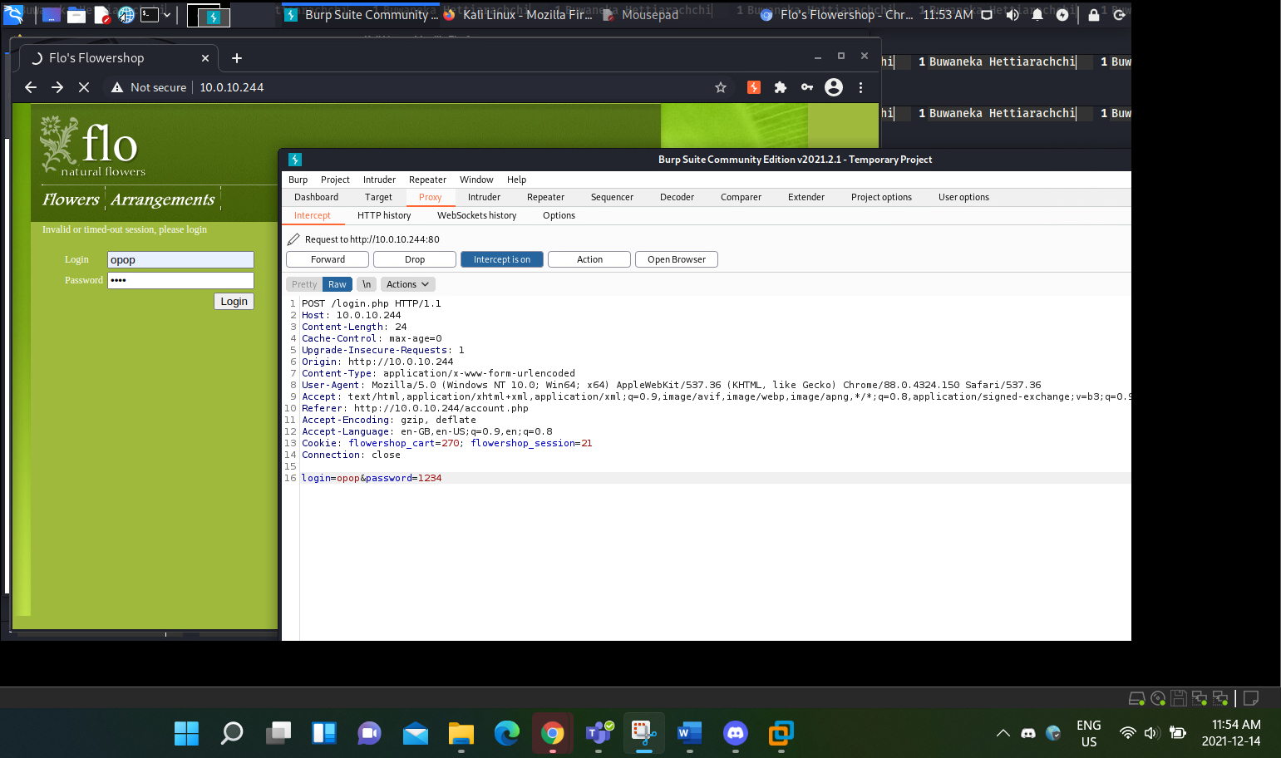

Figure 24: I turned on the interceptor and used a random username and password

As shown in the above Figure, we can come see that the output shows the login information that we applied, these information are the login username and the Password. By sending this Output to the Repeater we can see that the respond from that request is an Invalid Credential, which is obvious because we are trying to put in an Injection command to its place.

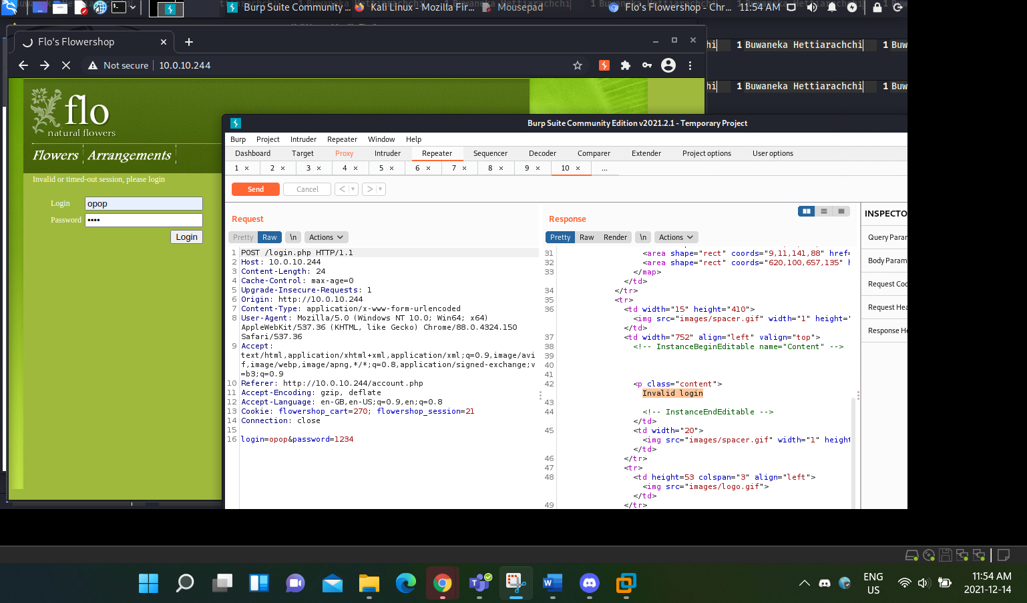

Figure 25: Response Showing that user credentials are invalid

So, to do an SQL injection for the Login, there is a command which is known as (‘ or 1=1 --) by doing this command, we will be able to manipulate the SQL database into doing action that will give unauthorized users privilege into other User information. For the password, I tried different approaches such as random passwords but for some reason, the Web application sent in an SQL error message saying that it couldn’t perform the given request, but then I tried to paste in the same SQL injection command into the password and it seemed to be working. As shown in the Figure below.

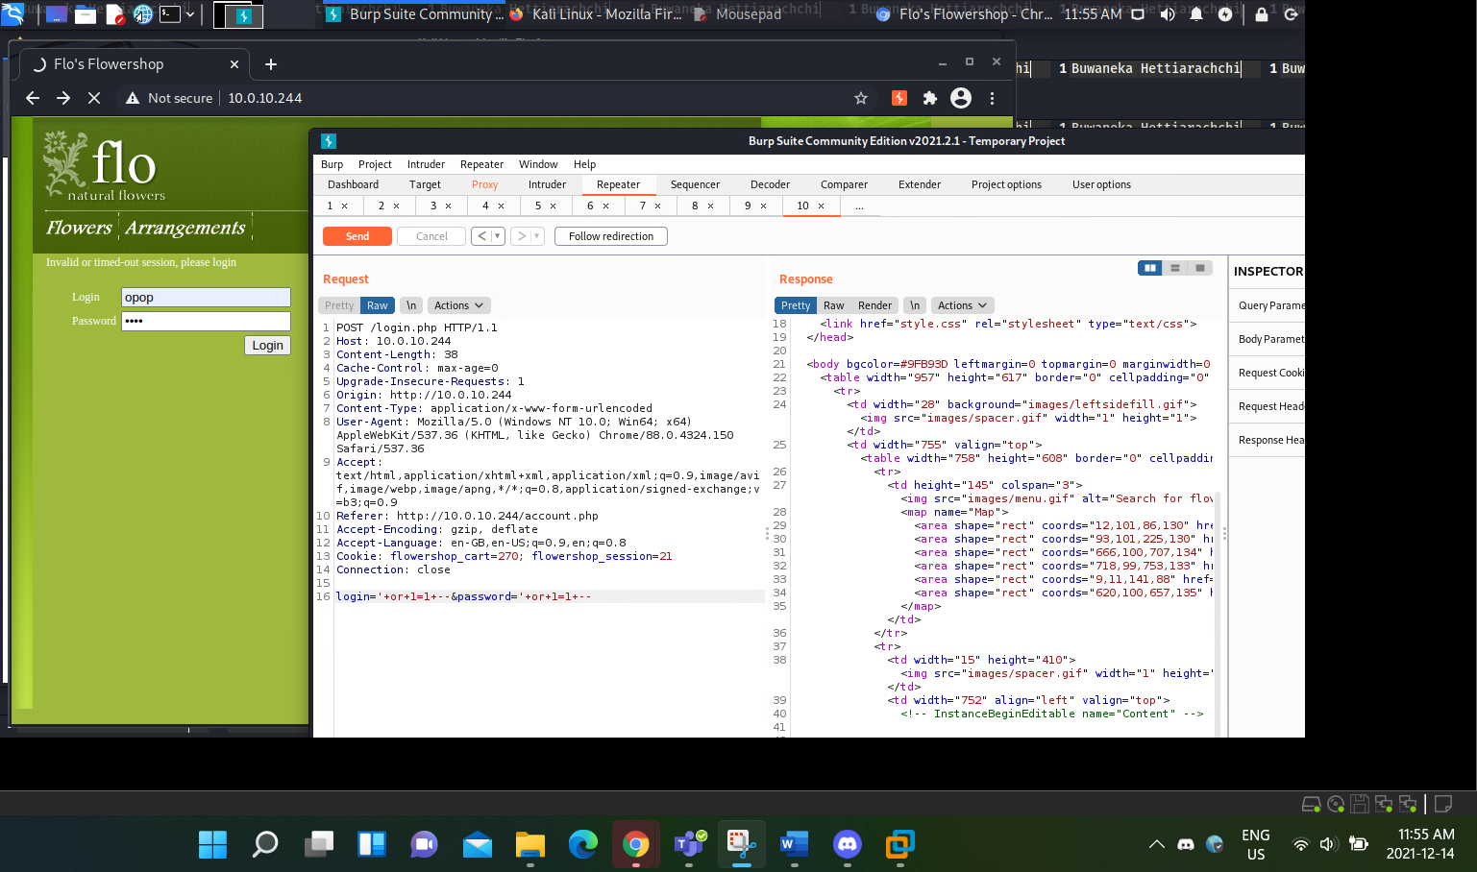

Figure 26: By changing the username to (' or 1=1 --) gives me response that is successful

Since this approach works and the Response from the repeater giving us a successful output, I went in and posted this to the Proxy Intercept page.

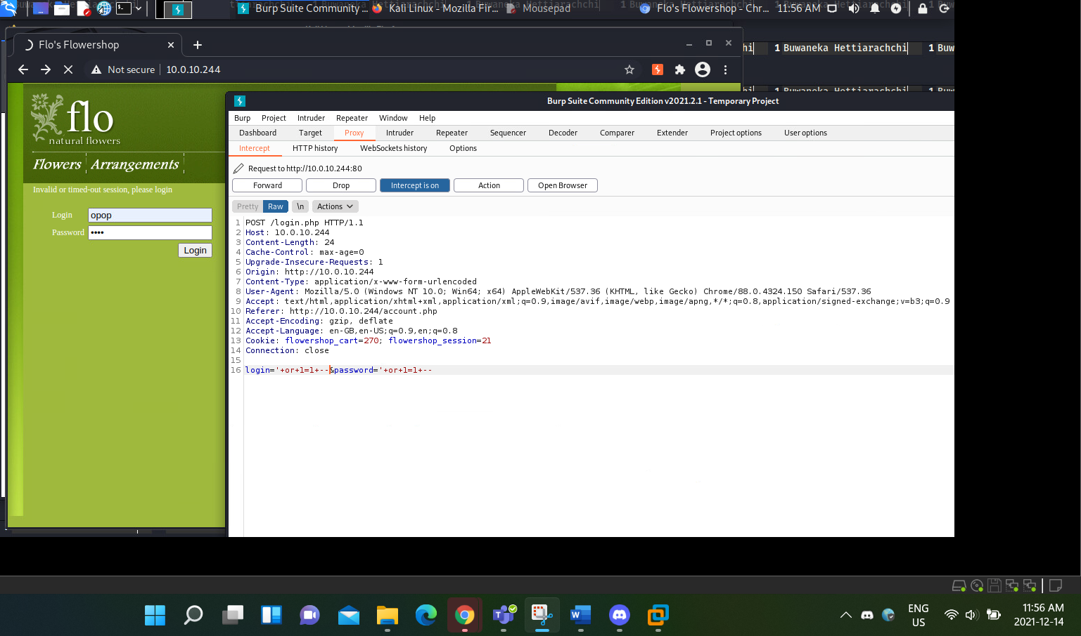

Figure 27: I will forward this to the webpage

After pasting that output I Forwarded the request in the Interceptor section of the Burp Suite, and It showed me the user GET request file for the credentials page of the user.

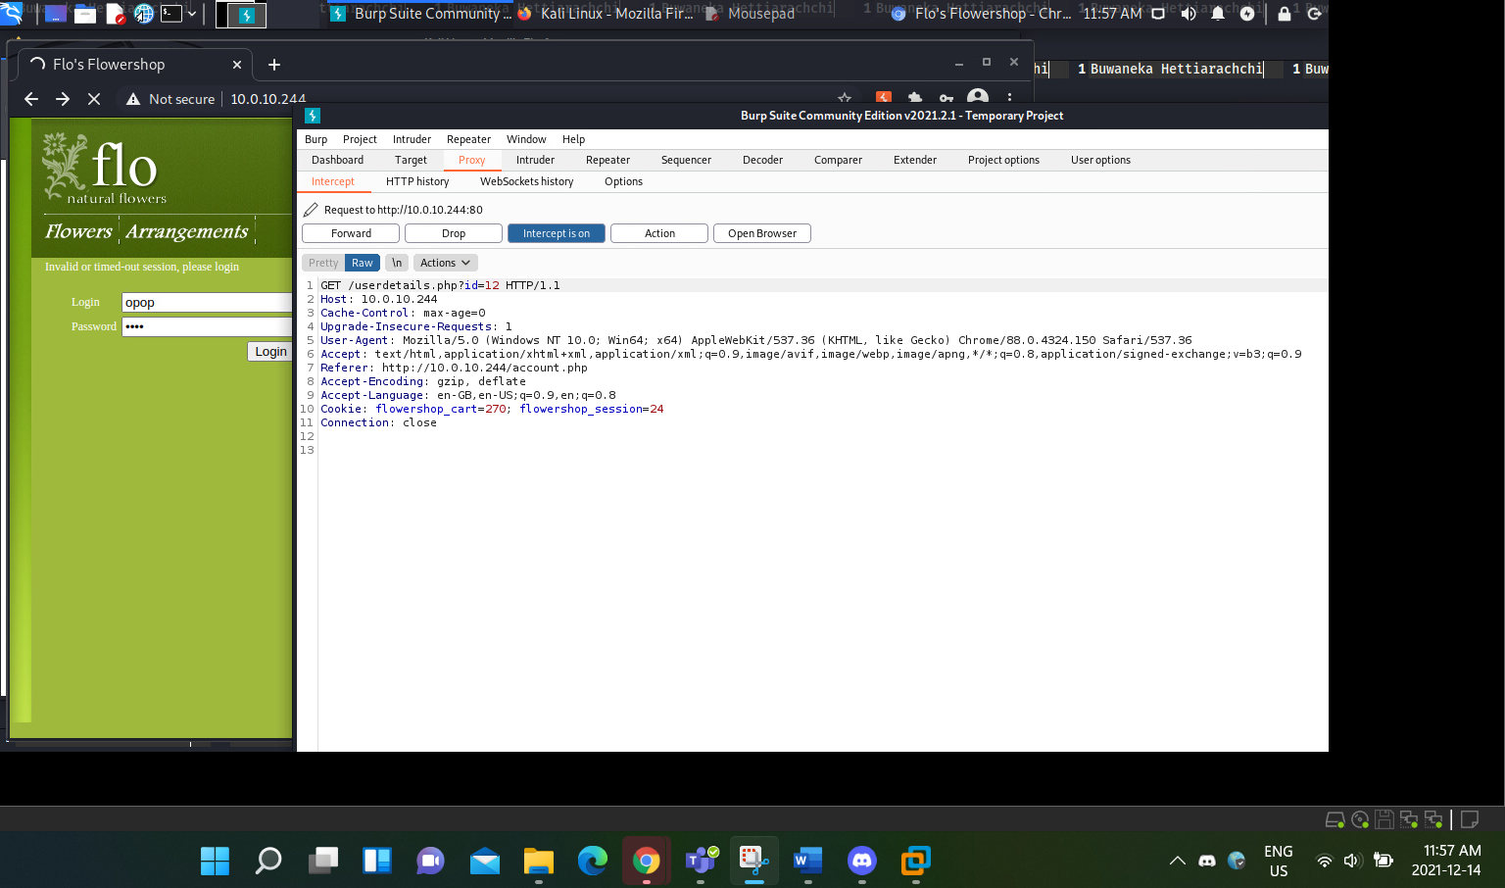

Figure 28: After forwarding the user information, it was successful

After seeing that I came to a realization that we will be forwarded to the user credentials file, the file that contained the login information of the User and the Credit card information.

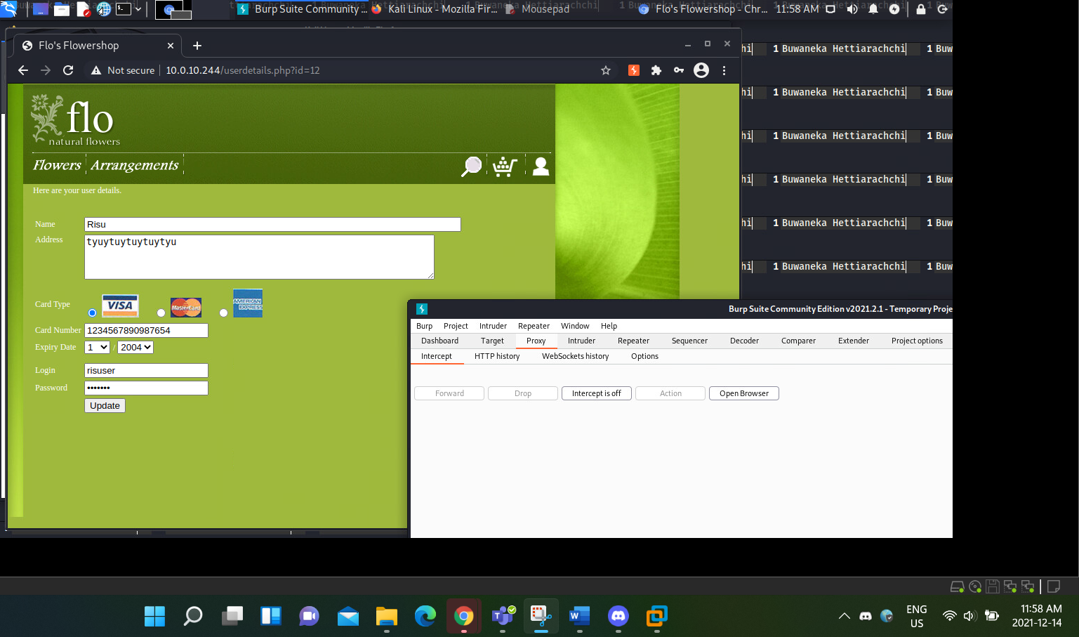

Figure 29: By turning off the Interceptor, we can see that we were successfully able to deliver the attack

As theorized, I have come to the user details page through the use an SQL injection, this page shows all the user information such as the Name of the user, the Address, and the Credit card information other than the Login information of the user.

# Technical Observations

1. Severity: High
2. Descriptive Tittle: Hidden Directories were visible and misconfigured which
3. Observation: What I observed was that most of the Hidden Directories Such as the Images directory, were visible in Bur Suite, but it was filtered. This doesn’t mean that it was only accessible for authorized users because when removing the filter, we were able to discover that any non authorized users can come into the files and view information about it. This also means that if the Image directory can be accessible to an unauthorized user, they can gain access to the Admin page.
4. Impact Statement: An attacker sees this and, will understand that anyone can access directories, this will make him do an attack that gives him access to the Admin page, which gives him Admin privilege that basically can clear user information or steal user information.
5. Evidence: Evidence is shown in Figure 1, where I am showing all the hidden directories that are just only filtered.
6. Assets Affected: the biggest asset that is affected is the Web application Flo Natural Flowers.
7. Recommendation: One of the biggest recommendations for the web application developer is to properly configure the directories and give it proper authentication where only the authorized personnel can access them, if an unauthorized user tries to access these files, restrict them.

# Appendix: Severity Definitions

## Broken Access Control: Administration Page

The severity state is high because, if an attacker is able to get into the administrative page that means that attacker has performed a lateral movement through the system and performed a privilege escalation, which gives the attacker the administrative privilege and could perform administrative tasks and take control of the whole web application. Plus, in most web applications, the administrative page is supposed to be a restricted area.

## Improper Input Validation: Manipulating the Cart

The severity state is critical, because there is a known vulnerability when adding in the quantity, an unauthorized user could manipulate the cart into giving them money, this will cause critical alert in the companies’ business standard.

## Cross Site Scripting: Performing an XSS Alert

The severity is critical, because what this does is that it will show up alerts whenever a user tries to go into a page that was affected by the XSS. In some cases, it would be so severe that the webpage will not be able to properly function, which in takes would be critical to the companies’ business model.

## Improper Input Validation: Changing the Upload File Type

The severity is high because, again the attacker will have unauthorized access to a restricted area of the target platform and the attacker uses unauthorized access to upload different malicious files hidden as a normal GIF file, but to do this, the attacker needs to go through the admin page to perform the attack.

## SQL Injection: Perform an SQL injection command in the Login

The severity of the attack is high because the attacker is inputting a malicious code to view the personal information of a consumer and the attacker is performing an unauthorized access towards the user details.

# Appendix: Host and services

The pen testing Environment was done in a Kali Linux platform where the penetration testing was performed on a web application known as Flo Natural Flower. The IP address of the Web application is 10.0.10.244.

# Appendix: Tool and services

The main tool that was used in this Lab Environment was called Burp Suite and it acted as the penetration tool. <https://portswigger.net/burp>

# Appendix: Additional Resources

<https://www.softwaretestinghelp.com/cross-site-scripting-xss-attack-test/>

<https://www.imperva.com/learn/application-security/sql-injection-sqli/#:~:text=SQL%20injection%2C%20also%20known%20as,lists%20or%20private%20customer%20details>.

<https://www.acunetix.com/websitesecurity/cross-site-scripting/>

<https://owasp.org/Top10/A01_2021-Broken_Access_Control/>